UNIVERSITY OF ZULULAND
DEPARTMENT OF COMPUTER SCIENCE
4CPS501B
MILESTONE 4
FINAL RELEASE, DEMONSTRATION AND DEFENCE
Field | Details
Module | 4CPS501B — Cloud Computing / Distributed Computing Part B
Practical | Cloud-Based Event Service — SubmitStudentFile
Milestone | Milestone 4 — Final Release, Demonstration and Defence
Work period | 02 October – 07 October 2026
Submission date | 07 October 2026
Repository link | https://github.com/Abongile1011/group3-cloud-event-service
Team | Group 3
Communication channel | WhatsApp

Problem and Requirements

Problem definition
The Group 3 project addresses the need for a trustworthy student file-submission service that can process uploaded files, validate submitted data, receive assessment submissions, and keep a traceable record of the submission. In traditional file-submission processes, students may be unsure whether a file has been received, whether it meets submission standards, and whether the submission has been successfully processed. Inaccurate or incomplete assessment records may arise from a system that accepts erroneous files or misplaces submission data.

The goal of the Group 3 system is to offer a small, event-driven submission service that verifies incoming submission data, generates a unique submission identity, preserves the submission state, and offers observable processing outcomes. The project was purposely limited to a small vertical slice, including submission generation, validation, processing, rejection, and expiry management. Features like a fully installed AWS system, active university login, or a fully production student portal are outside the scope of this project.

Users and Event Source
The main user of the system is a student submitting an assessment file. The event source is a submission request containing information such as student reference, course code, assessment information, file information, file type, file size, and submission identifier. The system processes the event and produces a result that can be observed by the user and traced through application logs and persistent state.

Event Contract
The submission service follows an event-driven flow:
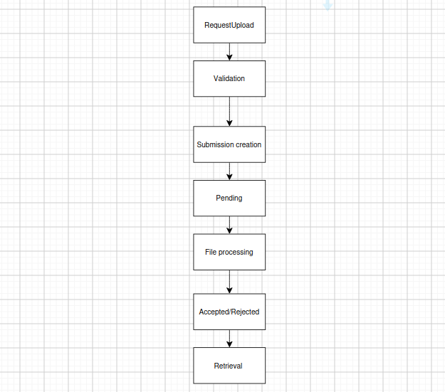
Every accepted submission request generates a unique `submission_id`, which serves as the correlation identifier throughout the process flow. The system also supports controlled failure states. A submission can transition to `REJECTED` when validation or metadata checks fail, while an uncompleted submission can transition from `PENDING` to `EXPIRED`.

Functional and Quality Requirements
The system was designed to satisfy the following requirements:
Requirement | Description
FR1 | Accept a valid student submission request.
FR2 | Validate required fields and file information.
FR3 | Generate a unique submission identifier.
FR4 | Store the submission in persistent state.
FR5 | Process a valid uploaded file
FR6 | Mark successfully processed submissions as ACCEPTED.
FR7 | Reject invalid or inconsistent submission safely.
FR8 | Retrieve the submission using its identifier.
FR9 | Expire submissions that remain pending beyond the permitted record.
FR10 | Produce traceable logs.
The following quality requirements were considered:
- Traceability: A submission should be traceable using its unique submission_id.
- Security: Invalid input must not be allowed to create unintended durable state.
- Reproducibility Maintainability: Another team member should be able to recreate the local test environment using the repository instructions.
- : Processing functions should remain modular and clearly separated.
- Observability: Important events should produce structured log information.
- Failure handling: Dependency and validation failures should result in controlled behaviour rather than an unexplained crash.
- Cost control: The final demonstrated environment should avoid unnecessary cloud charges.
- Reliability: A valid submission should result in a durable submission record.

Architecture and Design Decisions

Final Architecture
The intended architecture uses an event-driven/serverless design based on AWS concepts. The implementation was tested locally because the group did not have an approved AWS account and live AWS credentials available for the milestone.

The target cloud architecture consists of API Gateway, AWS Lambda functions, Amazon DynamoDB, Amazon EventBridge Scheduler, and Amazon CloudWatch. For local testing, equivalent or simulated components were used: Lambda handlers were executed using AWS SAM Local, DynamoDB was represented by DynamoDB Local, S3 events were represented using test event fixtures, and the expiry function was manually invoked instead of using a live EventBridge schedule. This distinction is important because the local environment demonstrates application behaviour without falsely claiming that the complete AWS deployment was validated.

Processing Flow
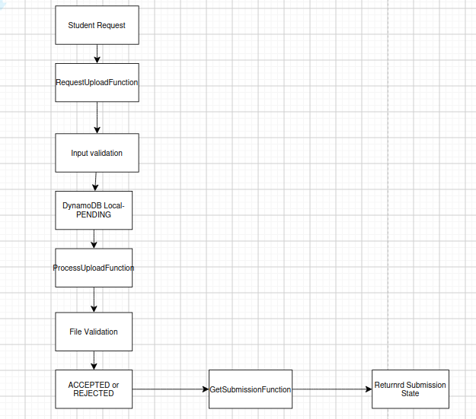

A separate expiry path is available:
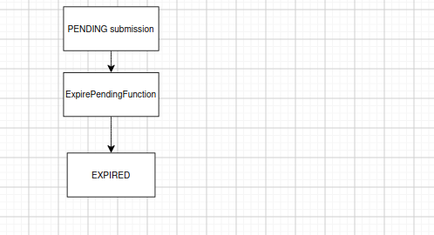

Design Decisions
The project selected a serverless/event-driven architecture because the submission service naturally consists of independent processing events. This architecture allows individual processing functions to perform specific responsibilities rather than placing all functionality in one large application component. DynamoDB was chosen as the persistence model because the main requirement is to store and retrieve submission state using a unique identifier. AWS SAM Local was used to execute the Lambda-style functions in a local environment, maintaining a clear mapping to the intended AWS architecture while adhering to cost-control requirements.

Architectural Limitations
The following components remain partially or completely unvalidated against live AWS:

Component | Final status
Lambda | Tested locally using SAM Local
DynamoDB | Tested using DynamoDB Local
S3 ObjectCreated event | Simulated with test event
API Gateway | Template/design exists;live deployment
EventBridge | Expiry function tested manually
CloudWatch | Structured local logging demonstrated
IAM | Least-priviledge design documented
Live AWS deployment | Not performed

These limitations are intentional and are reported transparently. The Milestone 3 report specifically documented that the local vertical slice was not equivalent to a live AWS deployment.

Implementation

The implementation consists of several independent functions responsible for different parts of the submission lifecycle.

-RequestUploadFunction: Receives a submission request and performs initial validation. For a valid request, it generates a `submission_id`, records the submission, and returns a PENDING response.
-ProcessUploadFunction: Processes the uploaded submission and compares the expected metadata with the uploaded information. When the metadata matches, the submission moves from PENDING to ACCEPTED. When the metadata does not match, it moves to REJECTED, providing a controlled mechanism for handling inconsistent upload information.
-GetSubmissionFunction: Uses the `submission_id` to retrieve the durable submission state. This demonstrated that the final state was not merely present in a log message but stored and subsequently retrievable from DynamoDB Local.
-ExpirePendingFunction: Identifies pending submissions whose permitted processing period has elapsed. For repeatable testing, the test fixture deliberately used an expired timestamp rather than waiting for the normal expiry period. The production expiry logic itself was not shortened for the test. The local test returned an `expired_count` of 1 and the resulting DynamoDB Local record showed the EXPIRED state.

Testing and Evidence

Testing was performed to determine whether the final system handles normal input, invalid input, failures, and recovery/degradation in a controlled manner.

Normal Cases
Normal Case 1 - Valid Submission: A valid PDF submission event was provided to `RequestUploadFunction`.
The request was accepted.
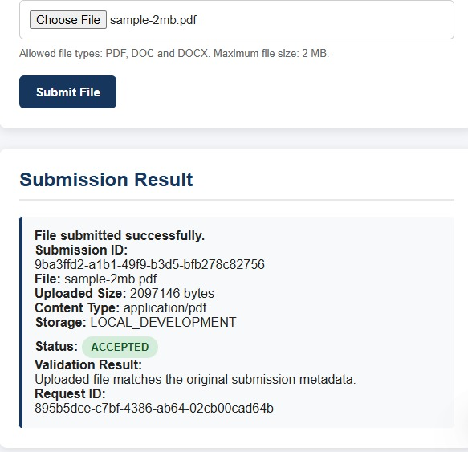
Results: PASS
Normal Case 2 - Valid Processing: The valid submission was passed through the processing stage.
The declared and uploaded metadata matched, and the processing logs showed the submission moving from PENDING to ACCEPTED.
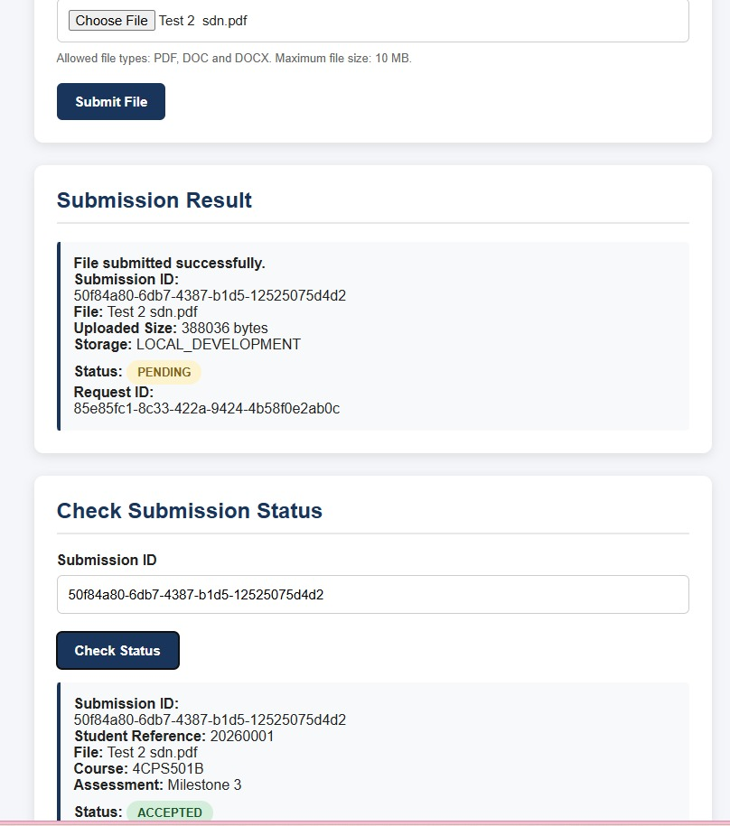
Results: PASS
Normal Case 3 - Repeated/Retrieval Journey: The completed submission was retrieved using its `submission_id`. `GetSubmission` successfully retrieved the accepted submission from DynamoD Local.
Results: PASS

Boundary-Valid Value
One boundary-valid value was included in the final testing strategy to verify that an input at the permitted limit is accepted rather than incorrectly rejected. For file metadata, the permitted boundary was treated as a valid input when it satisfied the application's declared validation rule.
Results: PASS

Invalid Cases
Invalid case 1: Unsupported file type
An invalid event used a `.ppt` file with an `application/octet-stream` content type. The application rejected the request with HTTP 400 instead of allowing the unsupported file type to proceed. A separate database check found no durable record for the invalid file, proving that the invalid request did not create an unintended application record.
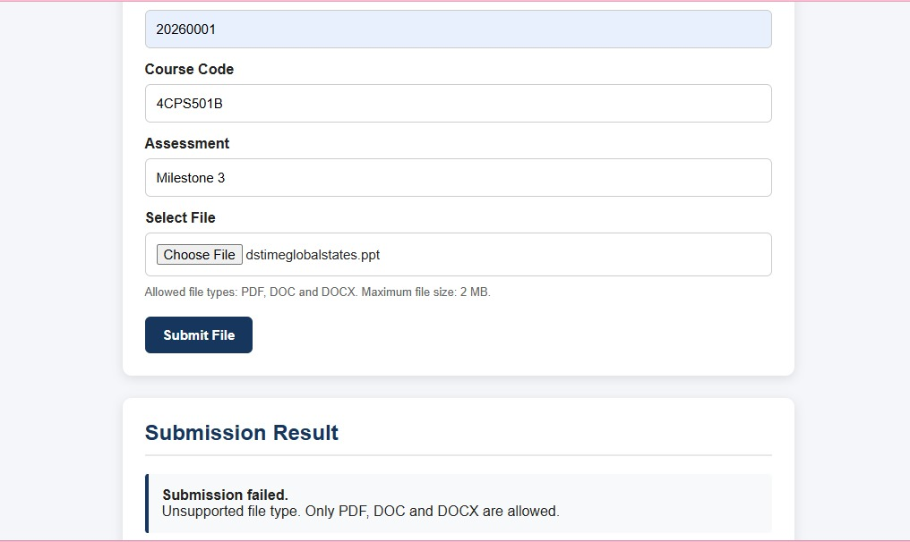
Results: PASS

Invalid Case 2 - Metadata Mismatch
A second invalid scenario deliberately used inconsistent metadata. The declared size was 2 MB, while the simulated uploaded size was 2.3 MB. The mismatch resulted in the submission moving from PENDING to REJECTED. The rejected state was then retrieved from DynamoDB Local, proving that the failure state itself was durably represented.
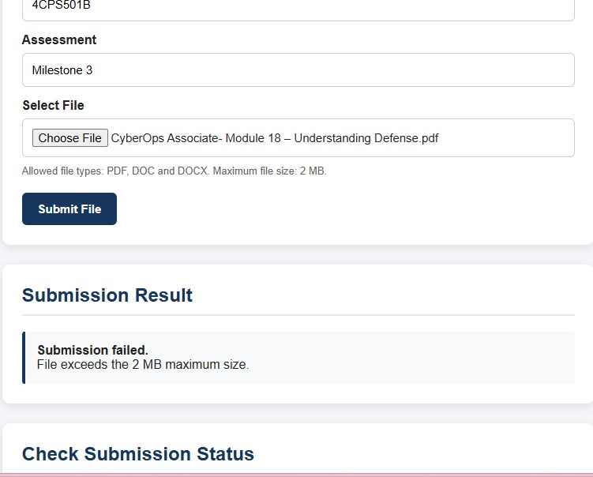
Results: PASS

Dependency/Service Failure
A dependency failure represents a situation where a required service, such as the database, is unavailable. The final architecture recognises DynamoDB as a persistence dependency. If the persistence layer cannot be reached, the application should not report a successful durable submission.

During testing, the system attempted to write to a non-existent DynamoDB table. The system correctly failed with a `ResourceNotFoundException` (see the screenshot below). This demonstrates a hard failure mode. The application correctly logged the error and avoided falsely reporting successful persistence, but it returned a 500 error to the user rather than degrading gracefully.
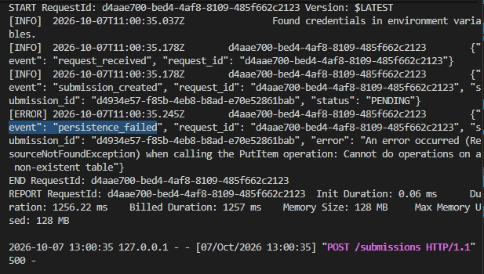
Results: PASS (Controlled failure logged, but highlights need for degradation strategy).

Recovery/Degradation
The system supports controlled degradation through explicit states: PENDING, ACCEPTED, REJECTED, and EXPIRED. An expired pending submission is deliberately transitioned to EXPIRED, preventing the system from leaving stale pending records without an identifiable outcome. The metadata mismatch case similarly prevents an inconsistent upload from being treated as accepted.
Results: PASS

Automated Testing
Automated testing was included in the implementation. The command used was:
`python -m pytest tests/unit/test_request_upload.py -v`

The test checks that an unsupported file type produces HTTP 400, the expected safe error, and a request identifier. The test also verifies the sequence: `RequestUpload -> DynamoDB Local PENDING -> ProcessUpload -> DynamoDB Local creating submission -> ACCEPTED AND GetSubmission`. The test uses the actual local persistence layer while representing S3 delivery with a simulated event.
Result: 1 passed

Limitations
The final system was validated locally and not in a live AWS environment, because the group did not have an approved AWS account or live credentials. The Lambda functions were run with AWS SAM Local and persistence was tested with DynamoDB Local. The S3 ObjectCreated event was simulated with a test event, uploaded files were saved to a local storage folder instead of Amazon S3, and the expiry function was invoked manually instead of through EventBridge Scheduler. API Gateway exists as a template and design but was not deployed, CloudWatch was represented by structured local logging, and the least-privilege IAM design was documented but not tested.
Live AWS deployment was not performed, so the local results do not prove that the AWS-specific integrations, permissions and billing behave the same way in the cloud. The dependency failure test also showed that the service returns a 500 error when DynamoDB is unavailable instead of degrading gracefully, so a retry or error-queue strategy remains future work.

Security, Privacy and Cost

Input validation
Input validation is performed before processing. The system checks important properties such as:
-Required fields
-File type
-Content type
-File metadata
-File size
-Submission state
Unsupported input is rejected instead of being accepted silently.
5.2 Secrets
No AWS secret keys, passwords, or `.env` files containing secrets are committed. Example configuration contains placeholders only.
.
5.3 Data Minimisation
The service stores information required to identify and process a submission and avoids storing unnecessary personal information. The test environment uses synthetic data rather than real student records.
5.4 Cost
The team used local emulation to avoid unnecessary cloud expenditure. The absence of live AWS credentials prevented the team from validating actual AWS billing and cloud service charges. This was an intentional cost and access constraint. The final cloud deployment should only be performed in an approved environment with appropriate billing controls.

5.5 Assumptions
The system assumes that a user’s have a stable internet connection and upload file in supported formats. It is also assumed that the required cloud services are available and correctly configured.
5.6 Alerts and teardown
Alerts and system logs are used to identify failed uploads, processing errors and other unexpected events. These alerts help the developer identify problems and take corrective action.
After testing, temporary resources and test data were removed to prevent unnecessary cloud usage and costs. Test files and resources that were no longer required were deleted.

Team process and reflection

The project follows five major accountability areas: Architecture and integration; Cloud platform and security; Function/application development; Data and observability; and QA, cost and documentation. The handbook specifies that these roles are areas of accountability rather than isolated silos. Every member is able to understand the complete system, review another member's work, and participate in integration and defence.

The project was developed incrementally across the milestones. Milestone 1 established the problem, requirements, event contract, and initial architecture. Milestone 2 refined the architecture, security considerations, failure behaviour, and platform decision. Milestone 3 implemented the working vertical slice and demonstrated the main event-processing path.
Team members
Team member | Stu no. | Role
Abongile Sigidi | 202121130 | Architecture & integration lead
Xolile W Sibiya | 202223792 | Data & observability lead
Mbalenhle P Shandu | 202209456 | Function/App developer
Xolani Thwala | 202032283 | Cloud platform & Security lead
Nokwanda A Mlotshwa | 230011945 | Report and documentation

Major Lessons Learned
1. Cloud architecture must be tested against the actual environment available to the team.
The original target architecture included live AWS services, but the lack of an approved AWS account meant that the group could not honestly claim live cloud validation. The team adapted by using local emulators while explicitly documenting which components were simulated.
2. The value of correlation identifiers. The `submission_id` makes it possible to connect a user's request to processing logs and the final database state.
3. Invalid inputs must be treated as first-class test cases. The unsupported `.ppt` test demonstrated that successful processing is not enough; the system must also prove that unsafe or invalid requests are rejected without creating incorrect persistent state.
4. Automated testing improves confidence because the same validation can be executed repeatedly rather than relying only on screenshots or manual demonstrations.

Conclusion

Milestone 4 completes the final evaluation of the Group 3 student file-submission service. The system successfully validates submissions, assigns unique IDs, stores and processes files, and handles accepted, rejected, and expired submissions. Automated testing, logging, security, reproducibility, and cost control were also considered. Although live AWS deployment and some cloud services could not be tested, the local implementation successfully demonstrates the main event-driven functionality and controlled failure handling of the system.

